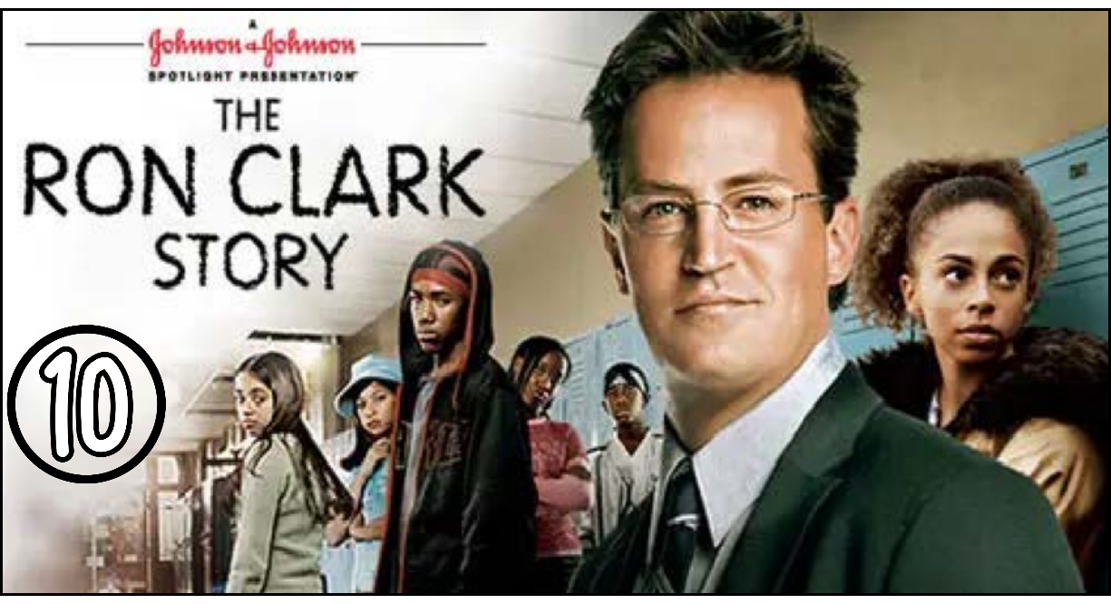

“The Ron Clark Story” (Scene 10)

Part 01 / Work on the Scene

- Scene summary:

“The scene starts when the ambulance is about to take Mr. Clark to the hospital, which makes the students very sad. Mr. Clark anticipated that he would not be able to teach his students for a while, so he recorded some lessons in video format and entrusted them to Mr. Turner to show to the students as a temporary solution until he could return. After recovering, Mr. Clark comes back to the school, but when he arrives, he is very upset because of the decline in his students’ performance. The students were afraid of the upcoming state test and felt unconfident, so he tried to encourage them, motivate them, and prepare them for the final exam.”

- Scene Discussion & Analysis:

- Q01: What happened to Mr Clark? Why was he taken to hospital?
“He fell down during the session. He was taken to the hospital because he was ill.”
Q02: Did he stay long at the hospital?
No, he didn’t.
- Q03: How did Mr. Clark use to deliver lessons from home while he was sick?
“He recorded the lessons in video format and gave them to Mr. Turner to be shown to the students.”
Q04: Was Mr. Clark happy with the homework scores of his students?
No, he wasn’t.
- Q05: Explain the message that Mr Clark wanted to convey in his final speech to his students. [speech starts from 03:50 to the end of the video]
- He wanted to tell them that if they believe in themselves, they can succeed in the test.

Part 02 / Acquired vocabulary & Grammar from the scene

- Acquired Vocabulary (OPTIONAL):

- To tape:to record something (on video or audio)
- Example in a sentence:
“ The teacher asked the students to tape the interview so they could watch it later.”
- To mess (something) up:to spoil, ruin, or make a mistake in something.
- Example in a sentence:
“ He messed up the presentation by forgetting his main points.”
- To choke [figure of speech]to fail under pressure, especially in an important situation (like in sports, exams, or performances).
- Example in a sentence:
“ She usually plays well, but during the final match she choked and lost the game.”

- Irregular Verbs:

Infinitive | Past simple | Past participle
To fall | fell | Fallen
To have | had | had
To show | showed | shown
To think | thought | Thought
To teach | taught | taught

Part 03 / TRANSCRIPTION: improve your listening (Optional)

Task: Transcribe sentences from the scene.

- Transcribe Sentence 01
- You gays have one week to the state exams one week to show Mr. Turner and your parents and your self’s what you can do

- Transcribe Sentence 02
- This roles the represent every think you have accomplished this year discovering new things believing in each other believing in your self’s and I am proud of you

- Transcribe Sentence 03
So next week you gonna take that test you gonna do the best that you can do and you are going to walk out of that room. And know you can do anything you want for the rest of your lifes.

Open discussion (OQ)

- Topic of discussion: During his sickness, Mr Clark found a way to deliver lessons to students through recorded videos. With the availability of the internet nowadays, it has become an acknowledged method of teaching. What do you think of remote (online) teaching!? What are the cons of the pros of online teaching? Can online teaching replace schools in the future permanently in your opinion?
(Students are free to participate and interact to share their own opinions.)
(Students are encouraged to prepare their arguments before the session.)

